Calculating **G** matrix metrics

In order to assess predictions of competing evolutionary hypotheses we will compare model predictions to observed data. The observed data will be published **G** matrices from the literature. A **G** matrix is a way of summarizing how much (additive) genetic variation is present in a trait and the (additive) genetic covariances between traits. **G** matrices are widely reported in the evolutionary literature because they tell us a lot about how populations can evolve and allow inferences about how populations might have previously evolved. For the big multi-population project a few years ago, all that work was ultimately to estimate the **G** matrices for each of the populations (if you want, you can read the final form of the associated paper at: [link](https://www.biorxiv.org/content/10.1101/619411v3), it’s also now been accepted for publication at the Proceedings of the Royal Society).

For this project, you’ll pull **G** matrices from the literature and then calculate a couple of different parameters describing these matrices. Specifically, you’ll calculate the *eigenvalues* of the matrices and the *effective dimensions* of the matrices. While you could, if you really wanted to, calculate both of these by hand I went ahead and made a small program so that you can do so automatically. The program can be accessed at:

<https://dochtermannlab.shinyapps.io/matrixmetricsapp/>

I set this up so that you can paste in matrices and then get the relevant metrics directly from the program. The main issue is that **G** matrices are often presented in very inconsistent ways. Often, authors will present genetic correlations in one part of the matrix and the covariances in another (typically referred to as above or below the diagonal. We’ll work through one example but it’s important to know that each paper might be somewhat difficult so you’ll have to carefully look over the reported values to make sure that what you’re inputting is appropriate.

Below is a screenshot from the lab of quantitative geneticist Mark Blows (Blows et al. 2004):

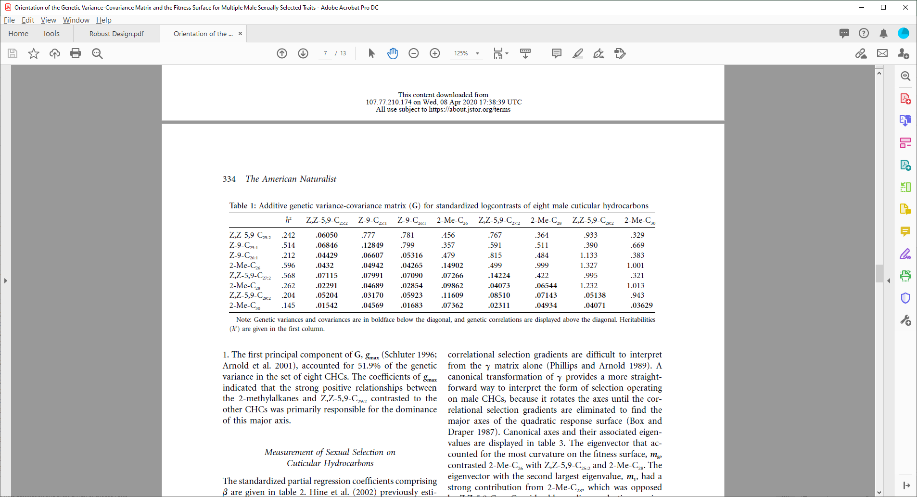

This table gives us the heritabilities for each of the traits (chemical components of their exoskeleton) as well as the variances and covariances that we want and correlations. So, what we want is this part of the table:

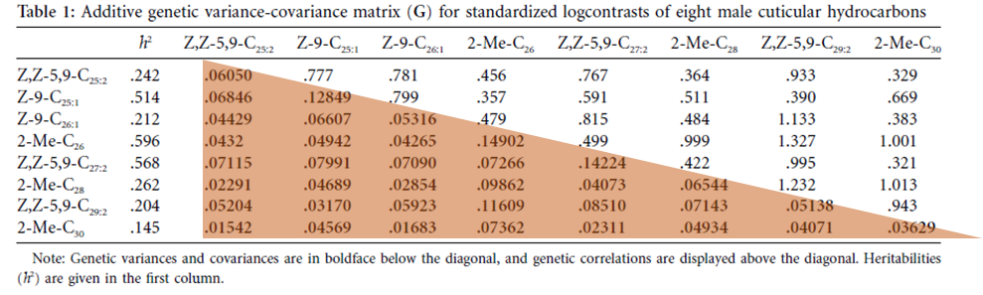

From the pdf, we can copy the table and paste it into excel. If you use the “Copy with formatting” option, you’ll potentially have less work to do. Otherwise, after you paste all the numbers will be in the same column, for each row. If that’s the case, go to “Data” on the Excel ribbon and click on “Text to Columns” and use “space” as the delimiter.

While not present here, one of the major issues you’ll run into is how minus/negative signs are imported. These will often require some editing of the table while in excel, we’ll work through that during our zoom session.

Once you have your matrix in text form, paste it into the first text box of the program (expand the box if needed to be able to see the entire thing. Then use the next entry box to tell the program how many traits are included in this matrix (the above one is 8).

In this case this should look like:

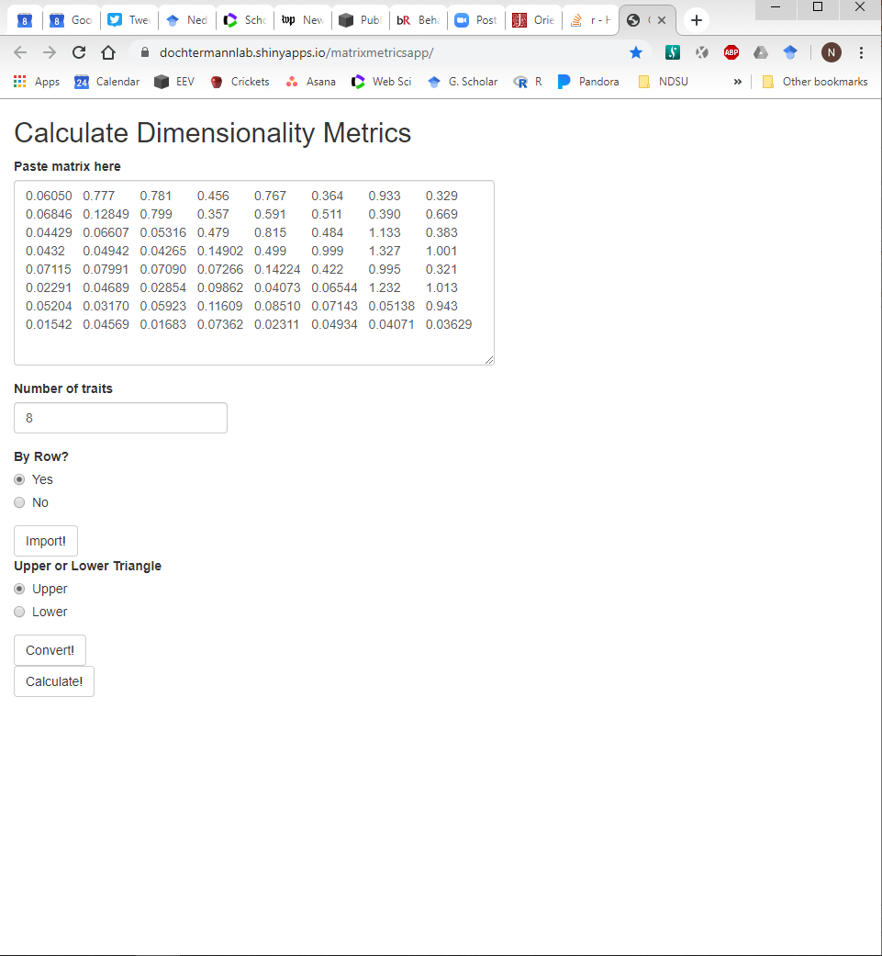

The next inputs are whether you want the table to be read in by row or by column. It’s unlikely you’ll ever need to change this but it’s an option. Therefore you can just click “Import!”. The window should now look like:

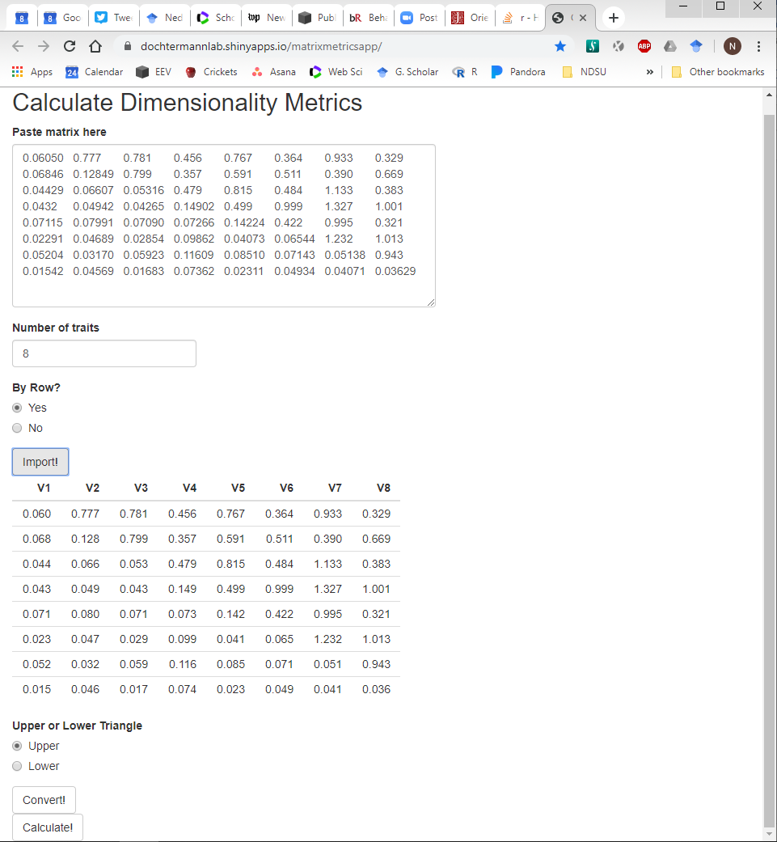

Next we have to specify if the covariances are in the top or bottom portion of the matrix (here they’re in the lower triangle of the matrix so select “Lower” and then click “Convert!”:

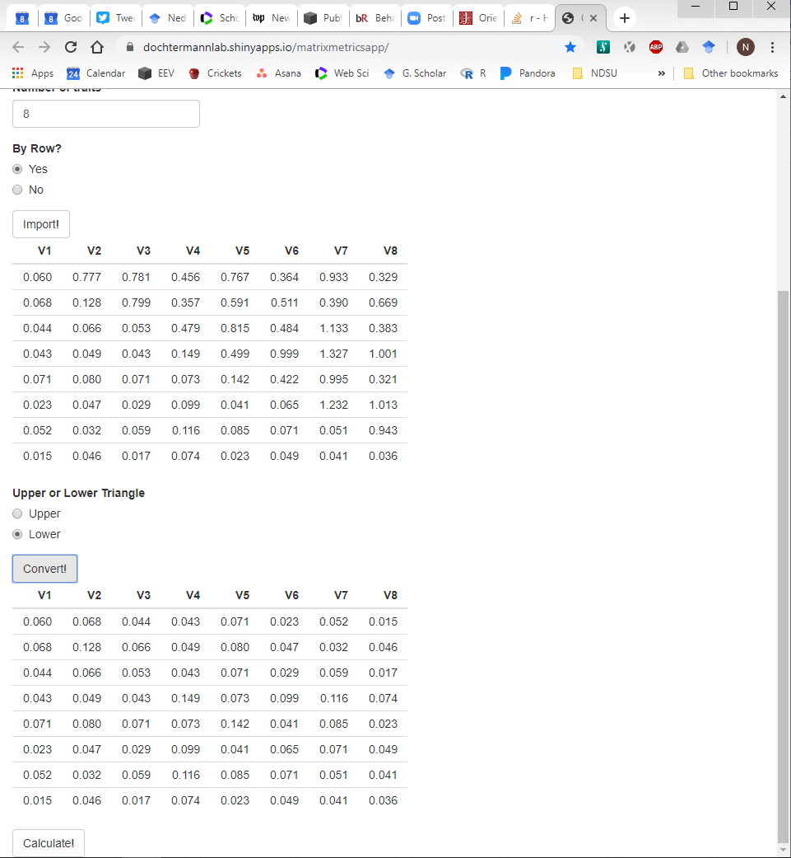

What “Convert!” does is to take just the relevant covariances and make what’s known as a “symmetrical matrix”. A symmetrical matrix is, as the name suggests, symmetrical around the main diagonal:

|  |  |  |  |  |  |  |  |  |
| --- | --- | --- | --- | --- | --- | --- | --- | --- |
| Not symmetrical | | | |  | Symmetrical | | | |
| 1 | 2 | 3 | 4 |  | 1 | 2 | 3 | 4 |
| 5 | 6 | 7 | 8 |  | 2 | 5 | 6 | 7 |
| 9 | 10 | 11 | 12 |  | 3 | 6 | 8 | 9 |
| 13 | 14 | 15 | 16 |  | 4 | 7 | 9 | 10 |

At this stage you want to carefully examine the converted matrix and compare it to the published matrix to make sure that all the information is in there correctly. Once you’re certain of that, click “Calculate!” and you’ll get this:

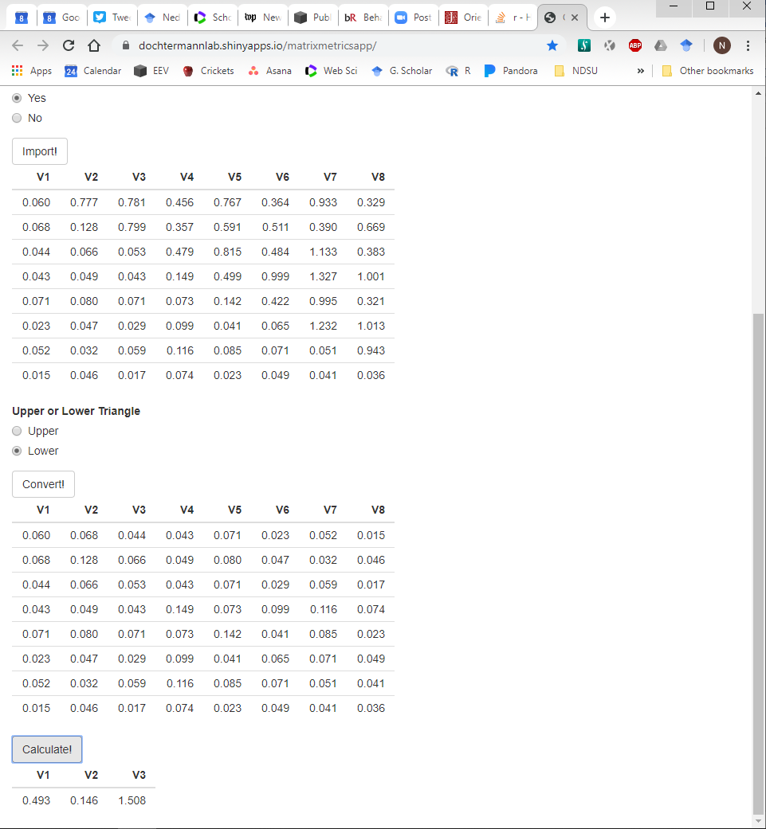

Those last three numbers are what we need. The first two are the *eigenvalues* and the third is the *effective dimensions*. These are what you’ll record in the supplied spreadsheet as lambda.1 and lambda.2 (the first and second eigenvalues) and as ndim (third value reported):

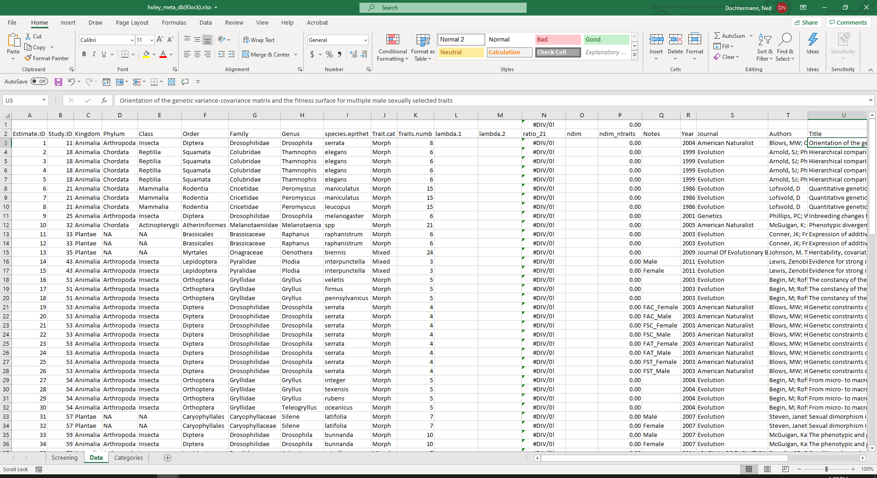

You’ll also want to populate the other columns of the spreadsheet with the relevant taxonomic, trait, and bibliographic information—which we’ll work through over zoom.

As you’re going through the various papers, feel free to refer back to this but also always contact me if you have any questions!

*References Cited*

Blows, M. W., S. F. Chenoweth, and E. Hine. 2004. Orientation of the genetic variance-covariance matrix and the fitness surface for multiple male sexually selected traits. American Naturalist **163**:329-340.